Beginners Guide to Pricing Tenders

As part of our tender consultancy service, I often discuss tender pricing strategies with clients. This beginners guide to pricing tenders covers the most common topics we talk about when aiming for the winning bid.
You know your business, its costs, competitive pricing and your competition – if you don’t, act now! I cannot tell you what will be the winning price. But this guide to pricing tenders explains some the most important issues when bidding to win a tender.
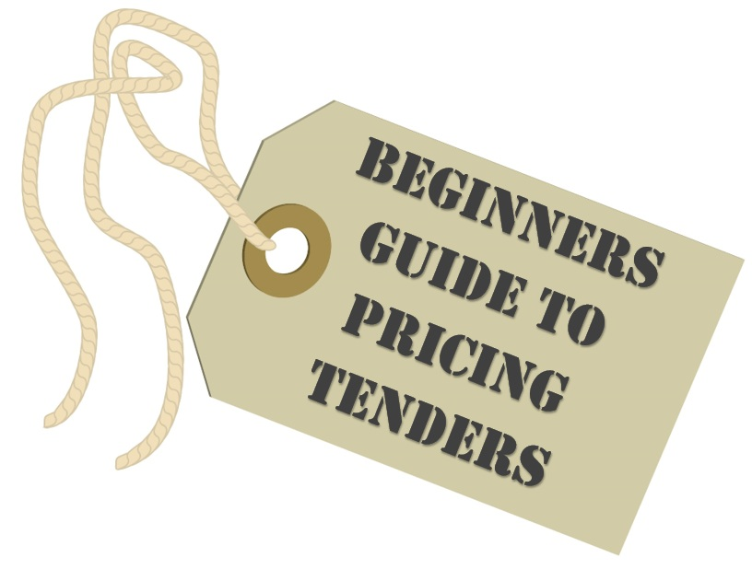
General Pricing Strategy
Tenders almost always have price as part of their evaluation (see MEAT below). So, you must ensure that your company’s pricing is competitive in your market sector.

When undertaking a sales and marketing review with a client, pricing strategies are always on the agenda (part of the Marketing Mix). This is a much bigger topic than pricing tenders and is too broad to cover properly in this post but let’s look at some of the basics:
There are three elements to a price:
- Direct Costs are the specific costs incurred to provide the product or servicee.g.staff, materials / sub-contractors and supervision
- Indirect Costs include premises , management , professional fees , administration etc.
- Profit is the difference between the selling price and (1)&(2)
Cost-plus pricing is a very common pricing methodology. You take into account all costs and then add your margin (e.g. percentage mark-up) to get to the selling price. You can then see how your prices compare with the market when making an acceptable profit. It’s a good starting point for pricing tenders.
Value-based pricing means selling at a price that customers are willing to pay. It may be higher than cost-plus. Especially if you offer something that is premium, scarce or needed urgently. Although in a commoditised market, you may find that it’s lower than cost-plus. In that case, you may need to review your costs and overheads or profits. Value-based pricing can be used in a tender to identify areas where you can charge more. e.g. when you know the value to the customer is more than cost-plus.
Marginal pricing looks at the differences in production levels. This a complex subject with many factors. A typical example is setting the price to cover the extra cost of producing an extra unit of output, plus a profit margin. You may consider marginal pricing when looking at spare capacity within your fixed overhead structure.
Economies of scale are the cost benefits resulting from higher outputs or increased scale of operation. A high-value 3-year contract may enable you to offer a reduced unit price.
Getting back to basics, it’s also worth looking at Why Companies Tender. Consider this when pricing tenders.
MEAT – Tender Evaluation
MEAT is the acronym for Most Economically Advantageous Tender. This means that a tender is evaluated or scored on a combination of price and quality. For example:
1. 70%price and 30% quality–the focus is low price 2. 30%price and 70% quality–the focus is on high quality
In example (1) you will need to be very keenly priced to win the tender; not necessarily the case in example (2).
Tenders are normally assessed upon the most economically advantageous tender. Apart from the lowest value purchases, all UK public sector tenders use MEAT.
You can read more about this in Understanding Tender Evaluation Criteria . Always look for specific weighting within the price evaluation when pricing tenders. For example, there might be certain parts that attract a higher score – concentrate on getting these right.

Firm Tender Price
An invitation to tender (ITT) requires you to submit a quotation not an estimate. That is a fixed, non-negotiable price offer which cannot be changed once accepted. There are types of tenders that allow some negotiation (e.g. ITNs – invitation to negotiate). But these are not common. It is rare to be given a chance to change to your tendered price. Public-sector ITTs normally state that there will not be any post-tender price alterations.
This means that you must be careful to properly cost for the stated requirement in the tender. If you discover an error once you’ve been awarded the contract, you can’t normally come back with a revised price. (Although you may be able to decline the contract award offer.) This is the case even if you find something that wasn’t in the ITT. For example, there may be a detailed specification in a cleaning or construction tender plus a chance to survey the premises. If you do not take the opportunity to survey, you may miss vital information that helps get the price ‘just right’.
Tender Compliance
In 10 Most Common Tendering Mistakes the first error is not completing the ITT’s pricing schedule correctly. If you don’t understand how to fill it out, seek help and/or ask for clarification.
The other 9 mistakes show that tenders need compliance and accuracy. (As well as a good price and quality response.)
Pricing Tenders Exactly
Following on from compliance, carefully read (and re-read) the specification, requirements and contract. This will help you to properly understand the contract. And therefore, price it correctly. You are in competition so don’t load extras in – these are added value. Price what’s asked for otherwise you may inflate your cost and become uncompetitive.
Your normal working methods might always include extra services. For example, providing a written report on completion of each job. If this isn’t asked for in the ITT and you include it in your price, you risk being unnecessarily more expensive. But the report may offer added value to the customer. This can help increase your quality score when responding to the tender questions.
My initial stance is to price exactly what’s asked for to maintain competitiveness. If the evaluation criteria favours quality over price, and added value gets high marks, then include costed ‘extras’.
What if you don’t like the limitations of the tender specification? Maybe you feel that it limits the quality or end result? Walk away. Better opportunities will come up soon enough.
Commercial View
Although I recommend Pricing Tenders Exactly, do temper this. Take a commercial view when pricing tenders. Consider the whole deal in a realistic manner. For example, there may be some items within the specification that have a high cost. But you know from experience that they only come in to play rarely. It might be a requirement to replace a serviceable unit which you know to be repairable 90% of the time. Instead of costing for a replacement on every unit, the commercial view is to cost for 10% replacements and 90% services.
Schedule of Rates (SOR) are common in the construction industry. SORs are price lists for a contract. Sometimes you insert your rates into the SOR. Others have pre-filled prices. You then offer your bid as a percentage increase, no change or an increase (e.g. +10%, neutral or -8%). Sometimes the SOR will show an evaluation weighting against certain items – aim to be very competitive on high-score prices.
You should know what are the high frequency items and those that crop up occasionally. Use your knowledge to create prices that are attractive. Lower some items and increase others. You should make the same money long-term. You want to offer a set of rates that will get you top marks.
Similarly, there might be penalties within the contract such as key performance indicators (KPIs). You should not ignore them. But if you know that the chance of you incurring such penalties is slim, do not let them put you off. If you perceive a high-risk, load the price or decline to bid.
Know Your Competitors
You may have a good idea of who else is bidding; the incumbent is a likely candidate for a start. Or you attend a Tender Briefing and see which of your competitors show up. Always consider what the opposition might do; their strengths, weaknesses and pricing. This can prove invaluable when finalising your tender pricing and bid submission.
Only Bid on Tenders You Can Win
It seems so obvious that you may wonder why I even mention it. But I constantly find that businesses are not qualifying tender opportunities.
Choose the right tenders and ignore anything else. This should help increase your tender success rate. If the tender isn’t right for you, it will suit a competitor who does fit the bill. They will be better placed to win the contact – no matter how good you are at pricing tenders.
If the tender sets out a budget or rates that are unprofitable for you. Don’t be afraid to walk away – let a competitor take the risk.
When times are tough, you get companies buying the work or suicide bidding. Avoid this at all costs.
Tender Pricing or Cost Breakdown
A common cause of concern is when a tender asks for breakdown of your price(s). Clients often ask how can I accurately calculate a breakdown? The short answer is that you don’t need to. The tender evaluation team are really only looking for a reasonable estimation. Typically, they are looking to see that important items are properly budgeted for. And that your overheads and profits are reasonable. For example, in a manpower service like cleaning or security they will be checking that you are paying enough to attract and retain good staff. And that the training you say you offer is fully-costed (if not, how can you provide the training?).
To recap, there are three elements to a price:
1. DirectCosts are the specific costs incurred to provide the product or service e.g. staff, materials / sub-contractors and supervision
2. Indirect Costs include premises,management,professional fees,administration etc.
3. Profit is the difference between the selling price and(1)&(2)
You may be asked to only show these three elements but often a more detailed breakdown is requested. This may be in the form of a percentage or in £s. Showing your direct costs and a breakdown of those tends to be easier than indirect costs and profit. If your business and product is very simple, it may be easy to calculate a breakdown. If you have a good estimating or pricing system you may have ready access to a breakdown. If you maintain management accounts, they can assist too.
If not, take a view and make an estimation. I always recommend looking at your company accounts to begin with. They will give you a better idea by showing some basics about your business’ costs and profits. However, they show your entire business over a year, not just the the contract you are bidding on. For example, you may make higher profits on smaller private sector contracts than on bigger public-sector contracts. Consider your customer and what’s important (e.g. wages and training). Then look at what is a reasonable profit to show – it doesn’t have to match your company accounts.
The biggest headache tends to be breaking down indirect costs. Especially if you have to price for multiple items on a tender. It is usually impossible to show one percentage breakdown that will reflect a true breakdown of each different price. So, take a view; look at the average over the contract. Then do a sense-check compared to your company accounts and pricing calculations.
As long as they are reasonably, realistic and you can confidently explain them if challenged, you should be OK. I have very rarely been asked to explain a breakdown at a short-list presentation or in post-tender clarifications.
But beware! Some buyers (typically corporate sector) will compare your pricing breakdown with your competitors. Highlighting where you are higher and asking you to reduce those elements. (They don’t tend to ask to make increases to match the competition!) You could end up reducing your total price (and profit) if you reduce everything to match. This calls for good negotiation.
Pricing Tenders for a Fixed Term
Some tenders ask for fixed pricing for up to 5 years. 2 – 3 years is not uncommon. This means that the contract will not allow uplifts for RPI, Government Minimum Wage increases or other direct costs. This puts you in a position of taking a measured risk in assuming what your costs will be for that period. This is a tricky one!
Recently inflation has been reasonably flat. But in the past, we have seen rapid inflation, fuel crises and other difficult to predict factors. It is quite likely to see something again within 5 years. All you can do is take a reasonable view in predicting what will happen based upon current knowledge.
The perceived risk is always that you won’t allow enough of an increase but of course, some costs might go down. You may well be able to drive some costs down over the contract period. This is easier in some industries where technology can reduce costs. Less so where manpower or fuel is the main cost e.g. cleaning or transportation.
My experience has been that ‘fixed costs’ are not always fixed. If costs increase beyond reasonable prediction, meet with the customer and explain the situation. Most customers will understand that you cannot operate at a loss and will come to a financial arrangement. Or agree a new specification that is affordable. If not, you may have to walk away. That itself gives the customer a headache as they may need to re-tender and incur cost of change. I appreciate that here may be contractual difficulties. Or the customer may wave contract clauses in front of you as a warning. However, a reasonable presentation of the facts normally gets results. I remember working for a company when fuel prices rocketed. Customers recognised the problem and allowed a price renegotiation.
Most contracts will allow for changes due to Government legislation. e.g. VAT, Minimum Wage, National Insurance etc.
Guaranteed Savings
The reason that buyers ask for fixed-term pricing is to provide certainty of cost. This helps to budget. For what it’s worth, I think there’s a more desirable option for the customer. That is seek better value for money each year. Not run ‘as is’ and squeeze the supplier. Hence some tenders ask you to state what specific savings you will make each year.
This is still tricky but tends to be easier than fixed-term pricing. Look at economies of scale and long-term efficiencies that you think you can achieve. These do not just need to be direct cost i.e. your tender price. They could be indirect costs i.e. your customer’s overhead.
You might be able to get a supplier to commit to a better price for a long-term deal. Or you may identify improvements which will save customer’s administration time. Offer a better deal for more than one lot in a multi-lot tender. Marginal pricing may help when offering savings on volume. Whole-life costs should be looked at too. e.g. your product may last longer than the tender’s requirement.
Show Tender Pricing Explanations
Not all tender pricing schedules or specifications make sense in the real world. This can be due to the customer not fully understanding your business or simply an error. It is always best to seek clarification. If that is not forthcoming, show anything that requires explanation clearly and unambiguously. Ideally on the pricing schedule.
But be very be careful of making qualifications i.e. “this price depends upon...” Many tenders specifically state that the tender must be submitted without qualification. If you think that you need to make qualifications, ask for clarification, take a Commercial View or walk away from the tender. This is part of your tender qualifying process.
Pricing explanations help make it easy for the evaluation team to understand how you priced your tender. They are not for caveats.
Alternative Bids
Some tenders invite you to submit an Alternative Bid. Some specifically forbid them. Where possible, offer an alternative. They tend to be well received and score higher marks.
Your alternative bid does not necessarily need to be a fully-costed alternative. You should show potential savings within your quality response. Then confirm them within the tender pricing schedule as a summary or note.
For example, the tender may specify ABC brand but you know you can make savings by using XYZ. For compliance, always give the customer what they ask for. In addition, offer the alternative, explaining the saving.
Measure Results
Tendering is selling and just like sales tenders are a number game. You will not win every bid. Depending on your market, good hit rates could be anything from 20% to 35+%. We’ve had runs of 100% tender success on 3-4 successive tenders for some clients. But we always know it cannot continue at that rate.
Keep track of your results. Always get tender feedback on how you did against your competitors. Win or lose – you want to know how you fared on tender pricing and quality versus the other bidders.
Benchmark your results. See if you need to trim some costs or identify where you can increase your prices and so make more profit.
Your aim should be to continually improve your bids and hit rates.
Conclusion
As I said at the start, I cannot tell you what will be the winning price. But if you use this guide when pricing tenders, you should increase your chances of success. Qualify each bid. Pitch competitively and in line with the tender requirements. Always keep track of the results compared to your competitors.
Pricing tenders is not easy and this guide only seeks to outline the basics. So please do add your thoughts, comments and ideas on how you approach pricing tenders.
What do you do about issues like fixed pricing, cost breakdowns and such?

